Record of Letter Ballot Review by TC Chapter for Procedural Review

Region/Locale: China
Global Technical Committee: Photovoltaic Materials
TC Chapter Cochairs: Guangchun Zhang/Canadian Solar
Standards Staff: Isadora Jin/SEMI China

 | Scheduled in Background Statement | Actual
Date | 5/22/2020 | 6/30/2020
Location | Shanghai | Shanghai
Reason for Change of Date and/or Location  (if changed) | Due to COVID-19 Virus

Note: See Regulations ¶ 9.5 Exceptions for allowable reason to change.

I. Document Number and Title
Document Number 6609 | Document Title  Revision to PV22-0817, Specification for Silicon Wafers for Use in Photovoltaic Solar Cells

II. Tally

Standards staff to fill in.

Voting Tally: As-cast tally after close of voting period

Note: A minimum of 60% of the Voting Interests that have TC Members within the global technical committee that issued the Letter Ballot must return Votes. (Regulations ¶ 9.6.2.1.1)

Voting Tally (with example values):
Note: See Regulations § 3.2.1 for definition of Voting Interest.
III. Rejects

Voting Interest Reject 1 (Voting Interest Name: Hanwha Q CELLS GmbH)
Voter Reject 1 (Voter: Max Koentopp and Hanwha Q CELLS GmbH)
Negative 1
Negative | Referenced Section/ Paragraph |  | *TF/TC Chapter to fill in, including text in the ballot if necessary.
 |  |  | Table 1 and Table 3
 | Negative Text |  | *Original complete Negative text (e.g., issue, justification, suggestion) should be copied.
All sizes that have a significant market share should be included. A standard should never exclude sizes currently in use by some manufacturers as machine restrictions make it difficult to adopt different sizes. A standard should not be used to negatively impact a specific manufacturer. The sizes proposed to be added are currently in use by several manufacturers with multi GW annual production volume:
Please add to Table 1 (square wafer) the following size: M4: 161,7 / 161,7±0,25 mm / 228,7±0,5 mm / 1,25±0,75 mm
Please add to table 3 (pseudo-square Wafers) the size: M4+: 161,7 II / 161,7±0,25 mm / 223±0,25 mm
TF input (optional)
Withdrawal (check one) |  |  | X | No Negative withdrawal made by Voter. |  |  |  |  |  | GO TO “Related” subsection
 |  |  |  | Withdrawal document received by Standards staff on MM/DD/YYYY. |  |  |  |  |  | GO TO “Final” subsection (A)
Related | Motion and Reason  (check one) |  | X | ‘Related’ is mutually agreed upon. (Needs no motion.) |  |  |  |  |  | GO TO “Persuasive” subsection
 |  |  |  | Negative is not related. (Needs ≥2/3 votes to pass.)
 |  |  |  | Reason |  | XXXX
 | Motion by/  2nd by |  | Name (Company)/Name (Company)
 | Discussion
 | Result of Vote (check one) |  | XX Y-XX N; Motion passed/failed.
 |  |  |  | [Negative is not related.] < 2/3 |  |  |  |  |  | GO TO “Persuasive” subsection
 |  |  |  | 2/3 ≤ [Negative is not related.] |  |  |  |  |  | GO TO “Final” subsection (B)
Persuasive | Motion and Reason  (check one) |  |  | Negative is related and persuasive. (Needs >1/3 votes to pass.)
 |  |  | X | Negative is related and not persuasive. (Needs ≥2/3 votes to pass.)
 |  |  |  | Reason |  | The Committee suggest to take reference of wafer developing trend. The size of M4 and M4+ is interim size during development. It is not wise to add not permanent size in standard. The Committee suggest to make specification standard for mainstream sizes at present and future. This will help the wafers’ sizes from different suppliers are unified and reduce capacity waste.
 | Motion by/  2nd by |  | Nannan Fu (LONGi)/Rulong Chen (Runergy)
 | Discussion |  | Rui Zhou (LONGi) Introduced the developing history of PV22.  Co-chair: It is suggested to discuss the majority size.  Wei Zhou (Trina): Can size 210 be added into this standard?  Co-chair: Size 210 is not majority at present. Please wait for more practice in PV industry.  Qiang Huang (Risen): I agree with Co-chair and Task Force.
 | Result of Vote (check one) |  | 34 Y-0 N; Motion passed.
 |  |  |  | [Negative is related and persuasive.] > 1/3 |  |  | Is a technical change recommended?  (check one) |  | Y | GO TO “Address by Technical Change Option” subsection
 |  |  |  | [Negative is related and not persuasive.] < 2/3 |  |  |  |  | N | GO TO “Final” subsection (E)
 |  |  |  | 2/3 ≤ [Negative is related and not persuasive.] < 90% |  |  | GO TO “Final” subsection (C)
 |  |  | X | 90% ≤ [Negative is related and not persuasive.] |  |  | GO TO “Not Significant Finding Option” subsection
Not Significant Finding Option | This option can be used only “if the TC Chapter finds a Negative not persuasive by a vote equal to or greater than 90% of the persons voting on the action”. (Regulations ¶ 9.6.1.4.5.2)
 | Use of “Not significant finding option”  (check one) |  | X | It is mutually agreed upon to term the Negative “not significant”. |  |  |  |  |  | GO TO “Final” subsection (D)
 |  |  |  | It is mutually agreed upon to term the Negative “significant”. |  |  |  |  |  | GO TO “Final” subsection (C)
 |  |  |  | Whether or not the Negative is “not significant” is decided by a vote.
 | Motion |  | The Negative is “not significant”.
 | Motion by/  2nd by |  | Name (Company)/Name (Company)
 | Vote |  |  | XX Y-XX N; Motion passed with simple majority |  |  |  |  |  | GO TO “Final” subsection (D)
 |  |  |  | XX Y-XX N; Motion failed with simple majority |  |  |  |  |  | GO TO “Final” subsection (C)
Final |  | (check if applicable) |  | (A) | Withdrawn (counted under h in disposition)
 |  |  |  | (B) | Not related (counted under i in disposition)
 |  |  |  | (C) | Related and not persuasive (significant)
 |  |  | X | (D) | Not significant (counted under j in disposition)
 |  |  |  | (E) | Related and persuasive and not addressed by technical change |  |  |  |  | DOCUMENT FAILS
 |  |  |  | (F) | Addressed by technical change (counted under k disposition)
 |  | (check if applicable) |  | Comment generated. See Section V-(ii) Comment # X.

Voting Interest Reject 1- Voter Reject 2 (Voter: Seungjun Lee and Hanwha Q CELLS GmbH)

Negative 1
Negative | Referenced Section/ Paragraph |  | *TF/TC Chapter to fill in, including text in the ballot if necessary.
 | Negative Text |  | *Original complete Negative text (e.g., issue, justification, suggestion) should be copied.
I request to add the new size wafers as follow ;
* For pseudo-square
M4+:161,7±0,25 mm / 223±0,25 mm
* For square
M4: 161,7±0,25 mm / 228,7±0,5 mm / 1,25±0,75 mm
Thanks.
TF input (optional)
Withdrawal (check one) |  |  | X | No Negative withdrawal made by Voter. |  |  |  |  |  | GO TO “Related” subsection
 |  |  |  | Withdrawal document received by Standards staff on MM/DD/YYYY. |  |  |  |  |  | GO TO “Final” subsection (A)
Related | Motion and Reason  (check one) |  | X | ‘Related’ is mutually agreed upon. (Needs no motion.) |  |  |  |  |  | GO TO “Persuasive” subsection
 |  |  |  | Negative is not related. (Needs ≥2/3 votes to pass.)
 |  |  |  | Reason |  | XXXX
 | Motion by/  2nd by |  | Name (Company)/Name (Company)
 | Discussion
 | Result of Vote (check one) |  | XX Y-XX N; Motion passed/failed.
 |  |  |  | [Negative is not related.] < 2/3 |  |  |  |  |  | GO TO “Persuasive” subsection
 |  |  |  | 2/3 ≤ [Negative is not related.] |  |  |  |  |  | GO TO “Final” subsection (B)
Persuasive | Motion and Reason  (check one) |  |  | Negative is related and persuasive. (Needs >1/3 votes to pass.)
 |  |  | X | Negative is related and not persuasive. (Needs ≥2/3 votes to pass.)
 |  |  |  | Reason |  | The negative is the same as voter 1.  Please see reason for voter 1.
 | Motion by/  2nd by |  | Nannan Fu (LONGi)/Wei Jiang (CPVT)
 | Discussion
 | Result of Vote (check one) |  | 35 Y-0 N; Motion passed.
 |  |  |  | [Negative is related and persuasive.] > 1/3 |  |  | Is a technical change recommended?  (check one) |  | Y | GO TO “Address by Technical Change Option” subsection
 |  |  |  | [Negative is related and not persuasive.] < 2/3 |  |  |  |  | N | GO TO “Final” subsection (E)
 |  |  |  | 2/3 ≤ [Negative is related and not persuasive.] < 90% |  |  | GO TO “Final” subsection (C)
 |  |  | X | 90% ≤ [Negative is related and not persuasive.] |  |  | GO TO “Not Significant Finding Option” subsection
Not Significant Finding Option | This option can be used only “if the TC Chapter finds a Negative not persuasive by a vote equal to or greater than 90% of the persons voting on the action”. (Regulations ¶ 9.6.1.4.5.2)
 | Use of “Not significant finding option”  (check one) |  | X | It is mutually agreed upon to term the Negative “not significant”. |  |  |  |  |  | GO TO “Final” subsection (D)
 |  |  |  | It is mutually agreed upon to term the Negative “significant”. |  |  |  |  |  | GO TO “Final” subsection (C)
 |  |  |  | Whether or not the Negative is “not significant” is decided by a vote.
 | Motion |  | The Negative is “not significant”.
 | Motion by/  2nd by |  | Name (Company)/Name (Company)
 | Vote |  |  | XX Y-XX N; Motion passed with simple majority |  |  |  |  |  | GO TO “Final” subsection (D)
 |  |  |  | XX Y-XX N; Motion failed with simple majority |  |  |  |  |  | GO TO “Final” subsection (C)
Final |  | (check if applicable) |  | (A) | Withdrawn (counted under h in disposition)
 |  |  |  | (B) | Not related (counted under i in disposition)
 |  |  |  | (C) | Related and not persuasive (significant)
 |  |  | X | (D) | Not significant (counted under j in disposition)
 |  |  |  | (E) | Related and persuasive and not addressed by technical change |  |  |  |  | DOCUMENT FAILS
 |  |  |  | (F) | Addressed by technical change (counted under k disposition)
 |  | (check if applicable) |  | Comment generated. See Section V-(ii) Comment # X.

Disposition of Voting Interest Reject 1

Check only when the Document has not been failed.

2 | Original number (#) of Negatives |  |  |  | (g)
# | Number of Negatives withdrawn |  |  |  | (h)
# | Number of Negatives found not related |  |  |  | (i)
2 | Number of Negatives found not significant |  |  |  | (j)
# | Number of Negatives addressed by technical change (Negative becomes not significant) |  |  |  | (k)
Final |  | X | g - (h + i +j + k) = 0 | Reject is Not Valid and is not included in the denominator of § VI. Approval Conditions Check
 |  |  | g - (h + i +j + k) >0 | Reject is included in the denominator of § VI. Approval Conditions Check
 |  |  | Reject without a Negative | Not Valid
This table is needed for each Voting Interest Reject.

Note: If all of the Negatives included with a Reject Vote are withdrawn, determined to be not related, or determined to be not significant, the Reject Vote is not valid. (Regulations ¶ 9.4.3.3)
Note: A Negative addressed by a technical change is automatically considered to be not significant. (Regulations ¶ 9.6.1.4.5.2)

Voting Interest Reject 2 (Voting Interest Name: Othman & Partners, LLP)
Voter Reject 1 (Voter: Maslina Othman and Othman & Partners, LL)
Negative 1
Negative | Referenced Section/ Paragraph |  | *TF/TC Chapter to fill in, including text in the ballot if necessary.
 |  |  | 8.1.1 Length, Width, or Diameter — Determine the edge length of rectangular and pseudo-square wafers by a method agreed upon between the supplier and the purchaser.
 | Negative Text |  | *Original complete Negative text (e.g., issue, justification, suggestion) should be copied.
 |  |  | Should this SEMI Standard provide suggestion of the Method? Rather than make it open to supplier and purchaser.
TF input (optional)
Withdrawal (check one) |  |  | X | No Negative withdrawal made by Voter. |  |  | GO TO “Related” subsection
 |  |  |  | Withdrawal document received by Standards staff on MM/DD/YYYY. |  |  | GO TO “Final” subsection (A)
Related | Motion and Reason  (check one) |  |  | ‘Related’ is mutually agreed upon. (Needs no motion.) |  |  | GO TO “Persuasive” subsection
 |  |  | X | Negative is not related. (Needs ≥2/3 votes to pass.)
 |  |  |  | Reason |  | Different testing methods depend on different types of sorting machine in the industry. There is no specific requirement for the specific detection methods. Wafer size testing method is beyond this standard’s scope.
 | Motion by/  2nd by |  | Nannan Fu (LONGi)/Wei Jiang (CPVT)
 | Discussion |  | None
 | Result of Vote (check one) |  | 35 Y-0 N; Motion passed.
 |  |  |  | [Negative is not related.] < 2/3 |  |  | GO TO “Persuasive” subsection
 |  |  | X | 2/3 ≤ [Negative is not related.] |  |  | GO TO “Final” subsection (B)
Final |  | (check if applicable) |  | (A) | Withdrawn (counted under h in disposition)
 |  |  | X | (B) | Not related (counted under i in disposition)
 |  |  |  | (C) | Related and not persuasive (significant)
 |  |  |  | (D) | Not significant (counted under j in disposition)
 |  |  |  | (E) | Related and persuasive and not addressed by technical change |  | DOCUMENT FAILS
 |  |  |  | (F) | Addressed by technical change (counted under k disposition)
 |  | (check if applicable) |  | Comment generated. See Section V-(ii) Comment # X.

Negative 2
Negative | Referenced Section/ Paragraph |  | *TF/TC Chapter to fill in, including text in the ballot if necessary.
 |  |  | 8.2.2 Resistivity — Determine the resistivity at the center of the wafer by the eddy current method using SEMI MF673 or SEMI PV28, as indicated on the purchase order or contract. If the wafers are single crystal or have few grain boundaries, the four-probe method may also be used in accordance with SEMI MF84 if agreed to by the supplier and purchaser.
 | Negative Text |  | *Original complete Negative text (e.g., issue, justification, suggestion) should be copied.
Does Semi Standard highly recommend PV suppliers to use Eddy as compared to four point probe? As far as I know working in industry, none of solar silicon wafer suppliers are using eddy current to measure their wafers resistivity. Put four point probe as SEMI Standard recommendation not Eddy current.
If there are differences results between the test method, share the differences in this document and the significant of the test method.
TF input (optional)
Withdrawal (check one) |  |  | X | No Negative withdrawal made by Voter. |  |  |  |  |  | GO TO “Related” subsection
 |  |  |  | Withdrawal document received by Standards staff on MM/DD/YYYY. |  |  |  |  |  | GO TO “Final” subsection (A)
Related | Motion and Reason  (check one) |  | X | ‘Related’ is mutually agreed upon. (Needs no motion.) |  |  |  |  |  | GO TO “Persuasive” subsection
 |  |  |  | Negative is not related. (Needs ≥2/3 votes to pass.)
 |  |  |  | Reason |  | XXXX
 | Motion by/  2nd by |  | Name (Company)/Name (Company)
 | Discussion
 | Result of Vote (check one) |  | XX Y-XX N; Motion passed/failed.
 |  |  |  | [Negative is not related.] < 2/3 |  |  |  |  |  | GO TO “Persuasive” subsection
 |  |  |  | 2/3 ≤ [Negative is not related.] |  |  |  |  |  | GO TO “Final” subsection (B)
Persuasive | Motion and Reason  (check one) |  |  | Negative is related and persuasive. (Needs >1/3 votes to pass.)
 |  |  | X | Negative is related and not persuasive. (Needs ≥2/3 votes to pass.)
 |  |  |  | Reason |  | At present, the test of wafer resistivity is completed in a sorting machine. The resistivity test module of the sorting machine is basically eddy current method testing. The four-probe testing is generally used for silicon ingot resistivity, not for wafer resistivity. Because four-probe testing has the problems of causing cracks and low test efficiency.
 | Motion by/  2nd by |  | Nannan Fu (LONGi)/Rulong Chen (Runergy)
 | Discussion
 | Result of Vote (check one) |  | 34 Y-1 N; Motion passed.
 |  |  |  | [Negative is related and persuasive.] > 1/3 |  |  | Is a technical change recommended?  (check one) |  | Y | GO TO “Address by Technical Change Option” subsection
 |  |  |  | [Negative is related and not persuasive.] < 2/3 |  |  |  |  | N | GO TO “Final” subsection (E)
 |  |  |  | 2/3 ≤ [Negative is related and not persuasive.] < 90% |  |  | GO TO “Final” subsection (C)
 |  |  | X | 90% ≤ [Negative is related and not persuasive.] |  |  | GO TO “Not Significant Finding Option” subsection
Not Significant Finding Option | This option can be used only “if the TC Chapter finds a Negative not persuasive by a vote equal to or greater than 90% of the persons voting on the action”. (Regulations ¶ 9.6.1.4.5.2)
 | Use of “Not significant finding option”  (check one) |  | X | It is mutually agreed upon to term the Negative “not significant”. |  |  |  |  |  | GO TO “Final” subsection (D)
 |  |  |  | It is mutually agreed upon to term the Negative “significant”. |  |  |  |  |  | GO TO “Final” subsection (C)
 |  |  |  | Whether or not the Negative is “not significant” is decided by a vote.
 | Motion |  | The Negative is “not significant”.
 | Motion by/  2nd by |  | Name (Company)/Name (Company)
 | Vote |  |  | XX Y-XX N; Motion passed with simple majority |  |  |  |  |  | GO TO “Final” subsection (D)
 |  |  |  | XX Y-XX N; Motion failed with simple majority |  |  |  |  |  | GO TO “Final” subsection (C)
Final |  | (check if applicable) |  | (A) | Withdrawn (counted under h in disposition)
 |  |  |  | (B) | Not related (counted under i in disposition)
 |  |  |  | (C) | Related and not persuasive (significant)
 |  |  | X | (D) | Not significant (counted under j in disposition)
 |  |  |  | (E) | Related and persuasive and not addressed by technical change |  |  |  |  | DOCUMENT FAILS
 |  |  |  | (F) | Addressed by technical change (counted under k disposition)
 |  | (check if applicable) |  | Comment generated. See Section V-(ii) Comment # X.

Disposition of Voting Interest Reject 2

Check only when the Document has not been failed.

2 | Original number (#) of Negatives |  |  |  | (g)
# | Number of Negatives withdrawn |  |  |  | (h)
1 | Number of Negatives found not related |  |  |  | (i)
1 | Number of Negatives found not significant |  |  |  | (j)
# | Number of Negatives addressed by technical change (Negative becomes not significant) |  |  |  | (k)
Final |  | X | g - (h + i +j + k) = 0 | Reject is Not Valid and is not included in the denominator of § VI. Approval Conditions Check
 |  |  | g - (h + i +j + k) >0 | Reject is included in the denominator of § VI. Approval Conditions Check
 |  |  | Reject without a Negative | Not Valid

IV. Other Technical Issues

Note: TC Chapter may choose to address a technical issue that is not part of a Negative received on a Letter Ballot (i.e., a Comment or a reason not addressed by a Vote response) by handling it as a Negative and finding it related and technically persuasive. The TC Chapter may then fail the Document or address such technical issue by using the procedure defined in Regulations § 9.6.1.4.3 to make a technical change to the Document. (Regulations ¶ 9.6.1.4.2.5)

Issue 1
Technical Issue |  | Origin |  |  | *TF/TC Chapter to choose  Comment # (Voter: Rui Zhou and LONGi) / A reason not addressed by a Vote response
 |  | Referenced Section/ Paragraph |  |  | *TF/TC Chapter to fill in including text in the ballot as appropriate.
 |  |  |  |  | Table 3, Table A1-1 Part 2, Table R1-2
 |  | Reason |  |  | *Original Comment text, if applicable, and problem statement, including justification and suggestion, should be copied.
Size 161 mm is not mainstream. It is better to be removed from this standard.
Size 166 mm should be specified as category I and category II
Handle technical issue identified above as a Negative.
Related |  | Motion and Reason  (check one) |  |  | X | ‘Related’ is mutually agreed upon. (Needs no motion.) |  |  |  |  |  |  |  | GO TO “Persuasive” subsection
 |  |  |  |  |  | Negative is not related and assigned to TF. (Needs ≥2/3 votes to pass.)
 |  |  |  |  |  | Negative is not related and placed on agenda of current TC Chapter meeting as new business. (Needs ≥2/3 votes to pass.)
 |  |  |  |  |  | Reason |  |  |  | XXXX
 |  | Motion by/  2nd by |  |  | Name (Company)/Name (Company)
 |  | Discussion
 |  | Result of Vote (check one) |  |  | XX Y-XX N; Motion passed/failed.
 |  |  |  |  |  | [Negative is not related.] <2/3 |  |  |  |  |  |  |  | GO TO “Persuasive” subsection
 |  |  |  |  |  | 2/3 ≤ [Negative is not related] and assigned to TF. |  |  |  |  |  |  |  | GO TO “Final” subsection (B)
 |  |  |  |  |  | 2/3 ≤ [Negative is not related] and placed on agenda of current TC Chapter meeting as new business.
Persuasive |  | Motion and Reason  (check one) |  |  | X | Negative is related and persuasive. (Needs >1/3 votes to pass.)
 |  |  |  |  |  | Negative is related and not persuasive. (Needs ≥2/3 votes to pass.)
 |  |  |  |  |  | Reason
 |  | Motion by/  2nd by |  |  | Rui Zhou (LONGi)/Zhen Zhang (Hohai University)
 |  | Discussion
 |  | Result of Vote (check one) |  |  | 35 Y-0 N; Motion passed.
 |  |  |  |  | X | [Negative is related and persuasive.] > 1/3 |  |  |  |  | Is a technical change recommended?  (check one) | X | Y | GO TO “Address by Technical Change Option” subsection
 |  |  |  |  |  | [Negative is related and not persuasive.] < 2/3 |  |  |  |  |  |  | N | GO TO “Final” subsection (E)
 |  |  |  |  |  | 2/3 ≤ [Negative is related and not persuasive.] < 90% |  |  |  |  | GO TO “Final” subsection (C)
Address by Technical Change Option |  | Technical Change Recommendations  Original section/paragraph number and at least one full sentence are required in “FROM” and “TO” fields.
 |  | Technical Changes | 1 | FROM: Section/Paragraph Table 3  Table 3 Dimensions of Pseudo-Square Silicon Wafers for PV Solar Cell Applications  Symbol in Figure 2^{#1} Dimensions (mm)  Dimension Name A (mm) Wafer Edge Length D (mm) Diameter  Nominal Size (mm) 100.75 100.75 ± 0.25 126 ± 0.25  125.75 125.75 ± 0.25 151 ± 0.25  156 I 156.75 ± 0.25 205 ± 0.25  156 II 156.75 ± 0.25 210 ± 0.25  158.75 158.75 $±$ 0.25 223 $±$0.25  161.7 161.7 $±$ 0.25 211 $±$0.25  166 166 $±$0.25 223 $±$0.25  166 166 $±$0.25 233 $±$0.25  210 210 $±$0.25 295 $±$0.25  Symbol in EN 50513 A E  Symbol in SEMI M6 A B
TO: Section/Paragraph Table 3
Table 3 mensions of Pseudo-Square Silicon Wafers for PV Solar Cell Applications
Symbol in Figure 2^{#1} |  | Dimensions (mm)
Dimension Name |  | A (mm)  Wafer Edge Length | D (mm)  Diameter
Nominal Size (mm) | 100.75 | 100.75 ± 0.25 | 126 ± 0.25
 | 125.75 | 125.75 ± 0.25 | 151 ± 0.25
 | 156 I | 156.75 ± 0.25 | 205 ± 0.25
 | 156 II | 156.75 ± 0.25 | 210 ± 0.25
 | 158.75 | 158.75 $±$ 0.25 | 223 $±$0.25
 | 161.7 | 161.7 $±$ 0.25 | 211 $±$0.25
 | 166 I | 166 $±$0.25 | 223 $±$0.25
 | 166 II | 166 $±$0.25 | 233 $±$0.25
 | 210 | 210 $±$0.25 | 295 $±$0.25
Symbol in EN 50513 |  | A | E
Symbol in SEMI M6 |  | A | B

Justification (If necessary)
Delete size 161.7 mm. Add category I and II.
 |  |  | 2 | FROM: Section/Paragraph Table A1-1, Part 2, 2-2.1  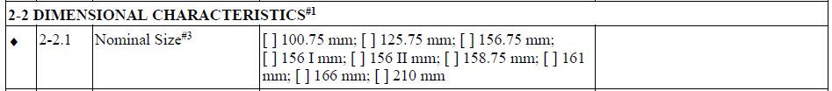
TO: Section/Paragraph Table A1-1, Part 2, 2-2.1
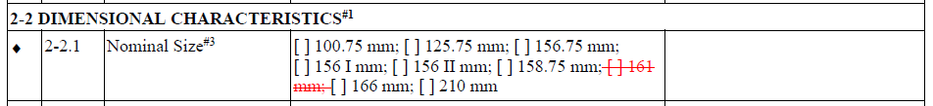
Justification (If necessary)
Delete size 161 mm.
 |  |  | 3 | FROM: Section/Paragraph Table A1-1, Part 2, 2-2.7  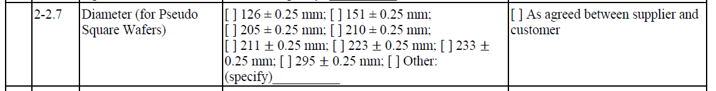
TO: Section/Paragraph Table A1-1, Part 2, 2-2.7
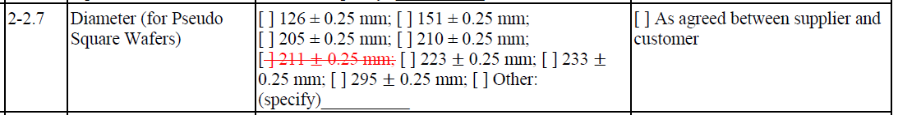
Justification (If necessary)
Delete size 161 mm corresponding diameter.
 |  |  | 4 | FROM: Section/Paragraph Table R1-2  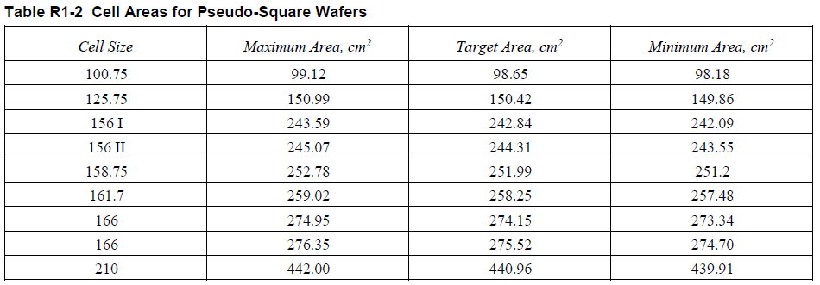
TO: Section/Paragraph Table R1-2
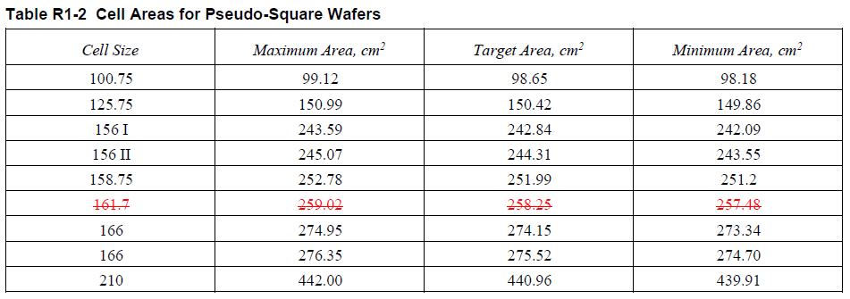
Justification (If necessary)
Delete cell areas of size 161 mm for Pseudo Square Wafers.
 |  | Motion |  |  |  |  | Negative is addressed by the technical change(s).
 |  | Motion by/2nd by |  |  |  |  | Nannan Fu (LONGi)/Zhen Zhang (Hohai University)
 |  | Discussion |  |  |  |  | Size 158.75 mm and size 161mm are transitional sizes that will not be permanent. It is not suitable to add size 158.75 mm and size 161mm.
 |  | Result of Vote (check one) |  |  |  |  | 35 Y-0 N; Motion passed.
 |  |  |  |  |  |  | X | 2/3 ≤ [Negative is addressed by the technical change(s).] |  |  |  |  |  | GO TO “Incorporation of the Technical Change” subsection
 |  |  |  |  |  |  |  | [Negative is not addressed by the technical change(s).] < 2/3 |  |  |  |  |  | GO TO “Final” subsection (E)
 |  | Incorporation of the Technical Change | Motion |  |  |  | To incorporate the technical change(s).
 |  |  | Motion by/2nd by |  |  |  | Nannan Fu (LONGi)/Zhen Zhang (Hohai University)
 |  |  | Discussion
 |  |  | Result of Vote (check one) |  |  |  | 35 Y-0 N; Motion passed.
 |  |  |  |  |  |  | X | 90% ≤ [Agree to incorporate.] |  |  |  |  |  | GO TO “Final” subsection (F)
 |  |  |  |  |  |  |  | [Disagree to incorporate.] >10% |  |  |  |  |  | GO TO “Final” subsection (E)
Final | (check one) |  |  |  |  | (B) |  |  | Not related
 |  |  |  |  |  | (C) |  |  | Related and not persuasive
 |  |  |  |  |  | (E) |  |  | Related and persuasive and not addressed by technical change |  |  |  |  | DOCUMENT FAILS
 |  |  |  |  | X | (F) |  |  | Addressed by technical change
 | (check if applicable) |  |  |  |  | Comment generated. See Section V-(ii) Comment # X.

Issue 2
Technical Issue |  | Origin |  |  | *TF/TC Chapter to choose  Comment # (Voter: Zhirong Guo and ZHONGHUAN) / A reason not addressed by a Vote response
 |  | Referenced Section/ Paragraph |  |  | *TF/TC Chapter to fill in including text in the ballot as appropriate.
 |  |  |  |  | Table 1
 |  | Reason |  |  | *Original Comment text, if applicable, and problem statement, including justification and suggestion, should be copied.
 |  |  |  |  | H(mm) Chamfer length of Dimension size 210mm is suggested to be corrected from 1.25±0.75mm to 2±0.65mm.
Handle technical issue identified above as a Negative.
Related |  | Motion and Reason  (check one) |  |  | X | ‘Related’ is mutually agreed upon. (Needs no motion.) |  |  |  |  |  |  |  | GO TO “Persuasive” subsection
 |  |  |  |  |  | Negative is not related and assigned to TF. (Needs ≥2/3 votes to pass.)
 |  |  |  |  |  | Negative is not related and placed on agenda of current TC Chapter meeting as new business. (Needs ≥2/3 votes to pass.)
 |  |  |  |  |  | Reason |  |  |  | XXXX
 |  | Motion by/  2nd by |  |  | Name (Company)/Name (Company)
 |  | Discussion
 |  | Result of Vote (check one) |  |  | XX Y-XX N; Motion passed/failed.
 |  |  |  |  |  | [Negative is not related.] <2/3 |  |  |  |  |  |  |  | GO TO “Persuasive” subsection
 |  |  |  |  |  | 2/3 ≤ [Negative is not related] and assigned to TF. |  |  |  |  |  |  |  | GO TO “Final” subsection (B)
 |  |  |  |  |  | 2/3 ≤ [Negative is not related] and placed on agenda of current TC Chapter meeting as new business.
Persuasive |  | Motion and Reason  (check one) |  |  | X | Negative is related and persuasive. (Needs >1/3 votes to pass.)
 |  |  |  |  |  | Negative is related and not persuasive. (Needs ≥2/3 votes to pass.)
 |  |  |  |  |  | Reason
 |  | Motion by/  2nd by |  |  | Zhirong Guo (ZHONGHUAN)/Rulong Chen (Runergy)
 |  | Discussion |  |  | Zhirong Guo (ZHONGHUAN): Tramfer length’s increasing can help reduce the risk of crack.
 |  | Result of Vote (check one) |  |  | 35 Y-0 N; Motion passed.
 |  |  |  |  | X | [Negative is related and persuasive.] > 1/3 |  |  |  |  | Is a technical change recommended?  (check one) | X | Y | GO TO “Address by Technical Change Option” subsection
 |  |  |  |  |  | [Negative is related and not persuasive.] < 2/3 |  |  |  |  |  |  | N | GO TO “Final” subsection (E)
 |  |  |  |  |  | 2/3 ≤ [Negative is related and not persuasive.] < 90% |  |  |  |  | GO TO “Final” subsection (C)
Address by Technical Change Option |  | Technical Change Recommendations  Original section/paragraph number and at least one full sentence are required in “FROM” and “TO” fields.
 |  | Technical Changes | 1 | FROM: Section/Paragraph Table 1  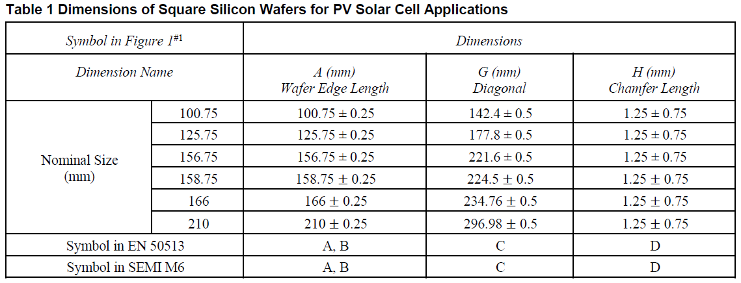
TO: Section/Paragraph Table 1
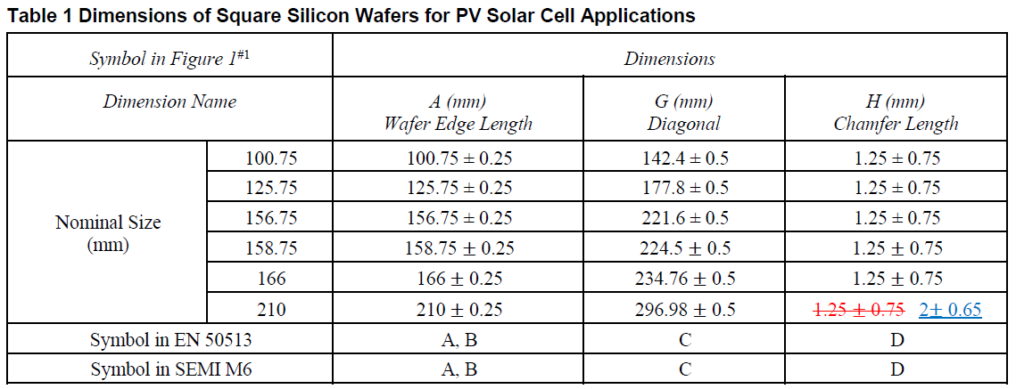
Justification (If necessary)
H(mm) Chamfer length of Dimension size 210mm is increased from 1.25±0.75mm to 2±0.65mm.
 |  | Motion |  |  |  |  | Negative is addressed by the technical change(s).
 |  | Motion by/2nd by |  |  |  |  | Zhirong Guo (ZHONGHUAN)/Zhen Zhang (Hohai University)
 |  | Discussion |  |  |  |  | Size 158.75 mm is a transitional size that will not be permanent. It is not suitable to add size 158.75 mm.
 |  | Result of Vote (check one) |  |  |  |  | 35 Y-0 N; Motion passed.
 |  |  |  |  |  |  | X | 2/3 ≤ [Negative is addressed by the technical change(s).] |  |  |  |  |  | GO TO “Incorporation of the Technical Change” subsection
 |  |  |  |  |  |  |  | [Negative is not addressed by the technical change(s).] < 2/3 |  |  |  |  |  | GO TO “Final” subsection (E)
 |  | Incorporation of the Technical Change | Motion |  |  |  | To incorporate the technical change(s).
 |  |  | Motion by/2nd by |  |  |  | Zhirong Guo (ZHONGHUAN)/Nannan Fu (LONGi)
 |  |  | Discussion
 |  |  | Result of Vote (check one) |  |  |  | 35 Y-0 N; Motion passed.
 |  |  |  |  |  |  | X | 90% ≤ [Agree to incorporate.] |  |  |  |  |  | GO TO “Final” subsection (F)
 |  |  |  |  |  |  |  | [Disagree to incorporate.] >10% |  |  |  |  |  | GO TO “Final” subsection (E)
Final | (check one) |  |  |  |  | (B) |  |  | Not related
 |  |  |  |  |  | (C) |  |  | Related and not persuasive
 |  |  |  |  |  | (E) |  |  | Related and persuasive and not addressed by technical change |  |  |  |  | DOCUMENT FAILS
 |  |  |  |  | X | (F) |  |  | Addressed by technical change
 | (check if applicable) |  |  |  |  | Comment generated. See Section V-(ii) Comment # X.

Issue 3
Technical Issue |  | Origin |  |  | *TF/TC Chapter to choose  Comment # (Voter: Qingxiang Lin and GCL) / A reason not addressed by a Vote response
 |  | Referenced Section/ Paragraph |  |  | *TF/TC Chapter to fill in including text in the ballot as appropriate.
 |  |  |  |  | Table 2
 |  | Reason |  |  | *Original Comment text, if applicable, and problem statement, including justification and suggestion, should be copied.
 |  |  |  |  | Please correct the percentage of the largest single grain of Cast Silicon Category I from 85% to 99%.
Handle technical issue identified above as a Negative.
Related |  | Motion and Reason  (check one) |  |  | X | ‘Related’ is mutually agreed upon. (Needs no motion.) |  |  |  |  |  |  |  | GO TO “Persuasive” subsection
 |  |  |  |  |  | Negative is not related and assigned to TF. (Needs ≥2/3 votes to pass.)
 |  |  |  |  |  | Negative is not related and placed on agenda of current TC Chapter meeting as new business. (Needs ≥2/3 votes to pass.)
 |  |  |  |  |  | Reason |  |  |  | XXXX
 |  | Motion by/  2nd by |  |  | Name (Company)/Name (Company)
 |  | Discussion
 |  | Result of Vote (check one) |  |  | XX Y-XX N; Motion passed/failed.
 |  |  |  |  |  | [Negative is not related.] <2/3 |  |  |  |  |  |  |  | GO TO “Persuasive” subsection
 |  |  |  |  |  | 2/3 ≤ [Negative is not related] and assigned to TF. |  |  |  |  |  |  |  | GO TO “Final” subsection (B)
 |  |  |  |  |  | 2/3 ≤ [Negative is not related] and placed on agenda of current TC Chapter meeting as new business.
Persuasive |  | Motion and Reason  (check one) |  |  | X | Negative is related and persuasive. (Needs >1/3 votes to pass.)
 |  |  |  |  |  | Negative is related and not persuasive. (Needs ≥2/3 votes to pass.)
 |  |  |  |  |  | Reason
 |  | Motion by/  2nd by |  |  | Qingxiang Lin (GCL)/Li Huang (SEMILAB)
 |  | Discussion
 |  | Result of Vote (check one) |  |  | 29 Y-6 N; Motion passed.
 |  |  |  |  | X | [Negative is related and persuasive.] > 1/3 |  |  |  |  | Is a technical change recommended?  (check one) | X | Y | GO TO “Address by Technical Change Option” subsection
 |  |  |  |  |  | [Negative is related and not persuasive.] < 2/3 |  |  |  |  |  |  | N | GO TO “Final” subsection (E)
 |  |  |  |  |  | 2/3 ≤ [Negative is related and not persuasive.] < 90% |  |  |  |  | GO TO “Final” subsection (C)
Address by Technical Change Option |  | Technical Change Recommendations  Original section/paragraph number and at least one full sentence are required in “FROM” and “TO” fields.
 |  | Technical Changes | 1 | FROM: Section/Paragraph Table 2  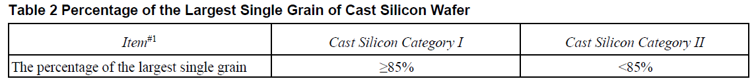
TO: Section/Paragraph Table 2
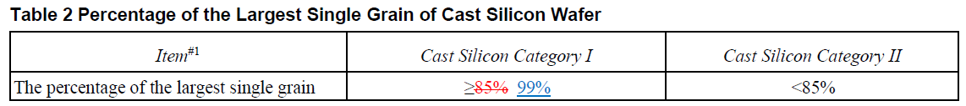
Justification (If necessary)
Correct the percentage of the largest single grain of Cast Silicon Category I from 85% to 99%.
 |  |  | 2 | FROM: Section/Paragraph Table A1-1, Part 2, 2-5.4
 |  |  |  | TO: Section/Paragraph Table A1-1, Part 2, 2-5.4
Justification (If necessary)
Correct the percentage of the largest single grain of Cast Silicon Category I from 85% to 99%.
 |  | Motion |  |  |  |  | Negative is addressed by the technical change(s).
 |  | Motion by/2nd by |  |  |  |  | Qingxiang Lin (GCL)/Li Huang (SEMILAB)
 |  | Discussion |  |  |  |  | Percentage of single grain of cast silicon wafer is larger than it was in the past several years. It is suggested to increase from 85% to 99%.
 |  | Result of Vote (check one) |  |  |  |  | 33 Y-1 N; Motion passed.
 |  |  |  |  |  |  | X | 2/3 ≤ [Negative is addressed by the technical change(s).] |  |  |  |  |  | GO TO “Incorporation of the Technical Change” subsection
 |  |  |  |  |  |  |  | [Negative is not addressed by the technical change(s).] < 2/3 |  |  |  |  |  | GO TO “Final” subsection (E)
 |  | Incorporation of the Technical Change | Motion |  |  |  | To incorporate the technical change(s).
 |  |  | Motion by/2nd by |  |  |  | Qingxiang Lin (GCL)/Li Huang (SEMILAB)
 |  |  | Discussion
 |  |  | Result of Vote (check one) |  |  |  | 33 Y-1 N; Motion passed.
 |  |  |  |  |  |  | X | 90% ≤ [Agree to incorporate.] |  |  |  |  |  | GO TO “Final” subsection (F)
 |  |  |  |  |  |  |  | [Disagree to incorporate.] >10% |  |  |  |  |  | GO TO “Final” subsection (E)
Final | (check one) |  |  |  |  | (B) |  |  | Not related
 |  |  |  |  |  | (C) |  |  | Related and not persuasive
 |  |  |  |  |  | (E) |  |  | Related and persuasive and not addressed by technical change |  |  |  |  | DOCUMENT FAILS
 |  |  |  |  | X | (F) |  |  | Addressed by technical change
 | (check if applicable) |  |  |  |  | Comment generated. See Section V-(ii) Comment # X.

Issue 4
Technical Issue |  | Origin |  |  | *TF/TC Chapter to choose  Comment # (Voter: Tao Xu and Canadian Solar) / A reason not addressed by a Vote response
 |  | Referenced Section/ Paragraph |  |  | *TF/TC Chapter to fill in including text in the ballot as appropriate.
 |  | Reason |  |  | *Original Comment text, if applicable, and problem statement, including justification and suggestion, should be copied.
 |  |  |  |  | 182mm*182mm (M10)’s wafer is suggested to be used in PV industry. This can drive PV industry developing.
Handle technical issue identified above as a Negative.
Related |  | Motion and Reason  (check one) |  |  | X | ‘Related’ is mutually agreed upon. (Needs no motion.) |  |  |  |  |  |  |  | GO TO “Persuasive” subsection
 |  |  |  |  |  | Negative is not related and assigned to TF. (Needs ≥2/3 votes to pass.)
 |  |  |  |  |  | Negative is not related and placed on agenda of current TC Chapter meeting as new business. (Needs ≥2/3 votes to pass.)
 |  |  |  |  |  | Reason |  |  |  | XXXX
 |  | Motion by/  2nd by |  |  | Name (Company)/Name (Company)
 |  | Discussion
 |  | Result of Vote (check one) |  |  | XX Y-XX N; Motion passed/failed.
 |  |  |  |  |  | [Negative is not related.] <2/3 |  |  |  |  |  |  |  | GO TO “Persuasive” subsection
 |  |  |  |  |  | 2/3 ≤ [Negative is not related] and assigned to TF. |  |  |  |  |  |  |  | GO TO “Final” subsection (B)
 |  |  |  |  |  | 2/3 ≤ [Negative is not related] and placed on agenda of current TC Chapter meeting as new business.
Persuasive |  | Motion and Reason  (check one) |  |  | X | Negative is related and persuasive. (Needs >1/3 votes to pass.)
 |  |  |  |  |  | Negative is related and not persuasive. (Needs ≥2/3 votes to pass.)
 |  |  |  |  |  | Reason
 |  | Motion by/  2nd by |  |  | Xinwei Niu (JA Solar)/Rulong Chen (Runergy)
 |  | Discussion |  |  | Xinwei Niu (JA Solar): 182mm*182mm (M10)’s wafer will be majority. This size should be added in PV22.  Rulong Chen (Runergy): I agree.
 |  | Result of Vote (check one) |  |  | 30 Y-4 N; Motion passed.
 |  |  |  |  | X | [Negative is related and persuasive.] > 1/3 |  |  |  |  | Is a technical change recommended?  (check one) | X | Y | GO TO “Address by Technical Change Option” subsection
 |  |  |  |  |  | [Negative is related and not persuasive.] < 2/3 |  |  |  |  |  |  | N | GO TO “Final” subsection (E)
 |  |  |  |  |  | 2/3 ≤ [Negative is related and not persuasive.] < 90% |  |  |  |  | GO TO “Final” subsection (C)
Address by Technical Change Option |  | Technical Change Recommendations  Original section/paragraph number and at least one full sentence are required in “FROM” and “TO” fields.
 |  | Technical Changes | 1 | FROM: Section/Paragraph Table 3  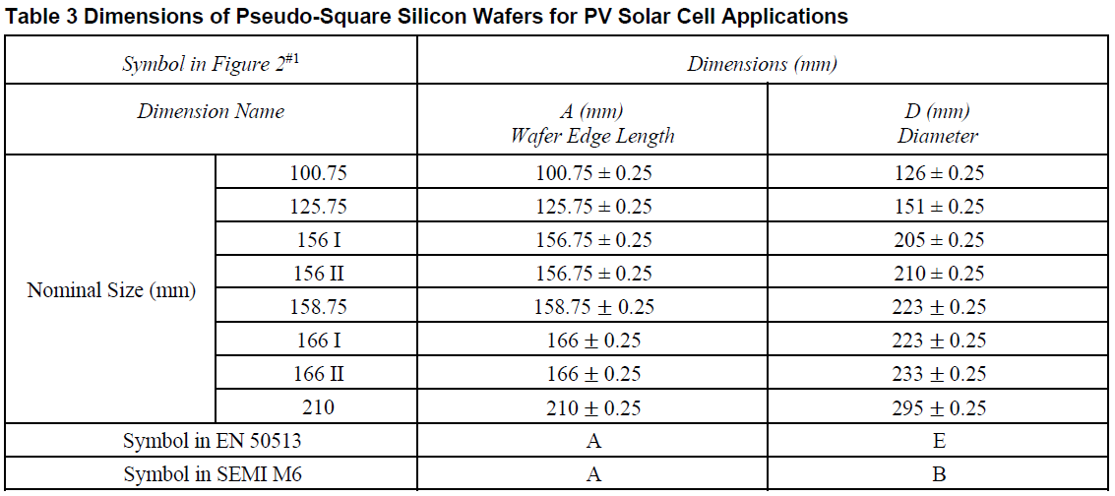
TO: Section/Paragraph Table 3
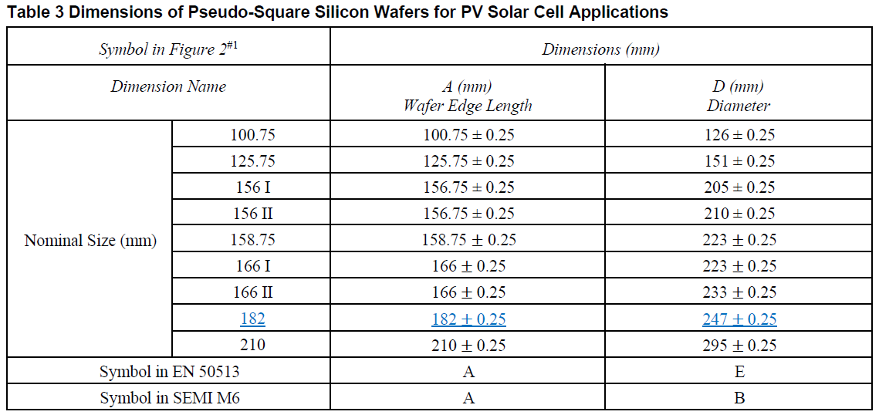
Justification (If necessary)
Add 182mm*182mm (M10)’s wafer, 182±0.25mm’s wafer edge length, 247±0.25mm’s diameter
 |  |  | 2 | FROM: Section/Paragraph Table A1-1, Part 2, 2-2.1  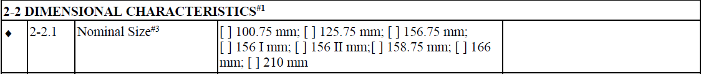
TO: Section/Paragraph Table A1-1, Part 2, 2-2.1
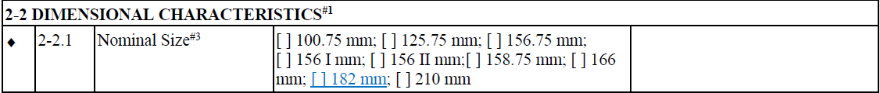
Justification (If necessary)
Add 182mm*182mm’s wafer
 |  |  | 3 | FROM: Section/Paragraph Table A1-1, Part 2, 2-2.7  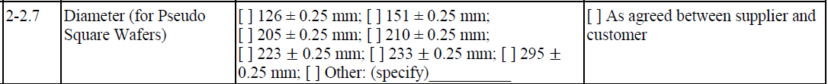
TO: Section/Paragraph Table A1-1, Part 2, 2-2.7
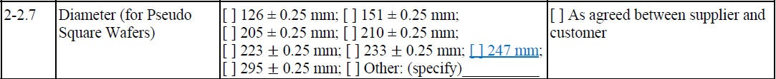
Justification (If necessary)
Add diameter of 182mm*182mm’s wafer
 |  |  | 4 | FROM: Section/Paragraph Table R1-2  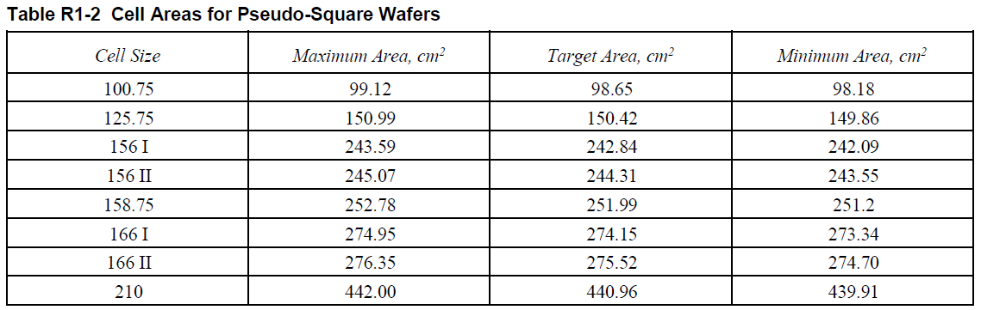
TO: Section/Paragraph Table R1-2
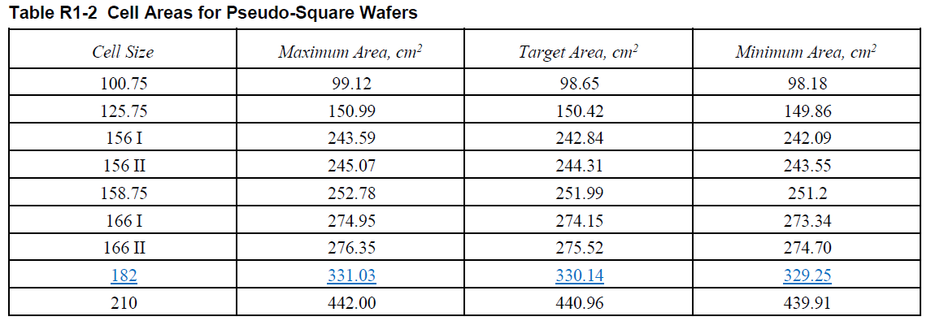
Justification (If necessary)
Add cell areas of 182mm*182mm’s wafer
 |  | Motion |  |  |  |  | Negative is addressed by the technical change(s).
 |  | Motion by/2nd by |  |  |  |  | Nannan Fu (LONGi)/Rulong Chen (Runergy)
 |  | Discussion |  |  |  |  | 182mm*182mm (M10)’s wafer, 182±0.25mm’s wafer edge length, 247±0.25mm’s diameter is suggested to be used in PV industry.
 |  | Result of Vote (check one) |  |  |  |  | 35 Y-0 N; Motion passed.
 |  |  |  |  |  |  | X | 2/3 ≤ [Negative is addressed by the technical change(s).] |  |  |  |  |  | GO TO “Incorporation of the Technical Change” subsection
 |  |  |  |  |  |  |  | [Negative is not addressed by the technical change(s).] < 2/3 |  |  |  |  |  | GO TO “Final” subsection (E)
 |  | Incorporation of the Technical Change | Motion |  |  |  | To incorporate the technical change(s).
 |  |  | Motion by/2nd by |  |  |  | Nannan Fu (LONGi)/Rulong Chen (Runergy)
 |  |  | Discussion
 |  |  | Result of Vote (check one) |  |  |  | 35 Y-0 N; Motion passed.
 |  |  |  |  |  |  | X | 90% ≤ [Agree to incorporate.] |  |  |  |  |  | GO TO “Final” subsection (F)
 |  |  |  |  |  |  |  | [Disagree to incorporate.] >10% |  |  |  |  |  | GO TO “Final” subsection (E)
Final | (check one) |  |  |  |  | (B) |  |  | Not related
 |  |  |  |  |  | (C) |  |  | Related and not persuasive
 |  |  |  |  |  | (E) |  |  | Related and persuasive and not addressed by technical change |  |  |  |  | DOCUMENT FAILS
 |  |  |  |  | X | (F) |  |  | Addressed by technical change
 | (check if applicable) |  |  |  |  | Comment generated. See Section V-(ii) Comment # X.

V. Comments

V- (i) Voters’ Comments
Commenter 1 (Peter Clawin/Hanwha Q CELLS GmbH) - Comment 1
Comment | *TF/TC Chapter to fill in section/paragraph #, if necessary.
The standard should include two further wafer sizes:
For pseudo-square
- M4+: 161.7 II / 161.7±0.25 mm / 223±0.25 mm
and
For square
- M4: 161.7 / 161.7±0.25 mm / 228.7±0.5 mm / 1.25±0.75 mm
These wafer sizes are currently in use with multi GW annual production volume. Not including these sizes would be a discrimination of manufactures currently using these sizes as machine restrictions make it difficult to switch to different wafer sizes.
Action | The TC Chapter agreed to do one of the following actions.
 | *No motion is required in this step.
 |  | Already addressed by Commenter #, Comment #
 | X | No further action was taken by the TC Chapter.  This comment is same as Voting Interest Reject 1
 |  | Refer to the TF for more consideration.
 |  | New Business
 |  | Editorial Change
 |  | Options for editorial  change (check one) |  |  | Case 1: No vote in this section:
 |  |  |  |  | To be included and voted on as a group in § VI. Editorial Changes Other than Those Voted on in § V.
 |  |  |  |  | Case 2: Voted in this section:
 |  |  |  |  | Original section number and at least one full sentence are required in “FROM” and “TO” fields.
Editorial Changes | 1 | FROM: Section/Paragraph xxx
 |  | TO: Section/Paragraph xxx
 |  | Justification (If necessary)
 | 2 | FROM: Section/Paragraph xxx
 |  | TO: Section/Paragraph xxx
 |  | Justification (If necessary)
Motion |  |  |  | To approve above editorial change(s)
Motion by/2nd by |  |  |  | Name (Company)/Name (Company)
Discussion |  |  |  | XXXX
Vote |  |  |  | XX Y-XX N; Motion passed/failed.
This table is needed for each Comment accompanied a Vote

V-(ii) Comments Created by Handling Negative

None

VI. Editorial Changes Other than Those Voted on in § V

None

VII. Approval Conditions Check

VII. - (i). Approval Rate

APPROVAL CONDITION 1: All Negatives have been discussed and were withdrawn, found not related, found not persuasive, or addressed by a technical change. (Regulations ¶ 9.6.2.1.2)

APPROVAL CONDITION 2: At least 90% of the sum of valid Voting Interest Accept and Voting Interest Reject Votes must be Accept. (Regulations ¶ 9.6.2.1.3)

Note: If both approval conditions are not satisfied, the Document fails.

VII. – (ii) Approval Level (check one)

Note: See Regulations § 9.6.2 for further information.

Globally Approved (No Ratification Ballot needed):
The Letter Ballot meets the Letter Ballot approval conditions for the global technical committee.
X | Need a Ratification Ballot:  The Letter Ballot meets the Letter Ballot approval conditions for the TC Chapter and a Ratification Ballot will be issued to validate technical changes.

VIII. Safety Check

Note: See Regulations § 15 for further information.

Motion | X | This is not a Safety Document, when all safety-related information is removed, the Document is still technically sound and complete. (Regulations ¶ 8.7.1)
 |  | This is a Safety Document, when all safety-related information is removed, the Document is not technically sound and complete. (Regulations ¶ 8.7.2)
 |  |  | Safety Checklist (Regulations ¶ 15.3) is complete and has been included with the Document throughout the balloting process. (Regulations ¶ 15.1.2)
Motion by/2nd by |  |  |  | Nannan Fu (LONGi)/Xinwei Niu (JA Solar)
Discussion |  |  |  | None
Vote |  |  |  | 35 Y-0 N; Motion passed

IX. Intellectual Property (IP) Check

Note: This Letter Ballot may cover all or part of a Standard or Safety Guideline. Regardless of the coverage, this IP check applies to the entire Standard or Safety Guideline*. See Regulations § 16 for further information.

X | The TC Chapter meeting chair asked those participating, if they were aware of any patented technology that might be relevant (see Regulations ¶ 16.3.1.1) to the Standard or Safety Guideline; or, any copyrighted items or trademarks that are used/reproduced (see Regulations ¶ 16.4.1.2) in the Standard or Safety Guideline. (Also see, Regulations § 8.8)
 | X | The question is NOT answered in affirmative (No potentially material patented technology or use/reproduction of copyrighted items/trademarks is known.) | GO TO SECTION X.
 |  | The question is answered in affirmative | Is any of the known IPs a patented technology? |  | Yes, at least one of them is a patented technology | GO TO IX (a) “Patented Technology” subsection
 |  |  |  |  | No | GO TO IX (b) “Copyright items” subsection

X. Action for This Document
Motion |  | This Document passed TC Chapter review as balloted and will be forwarded to the ISC A&R SC for procedural review.
 |  | This Document passed TC Chapter review with editorial changes and will be forwarded to the ISC A&R SC for procedural review.
 | X | This Document passed TC Chapter review with technical changes and with or without editorial changes and will be forwarded to the ISC A&R SC for procedural review. A Ratification Ballot will be issued to verify the technical changes.
 |  | This Document failed TC Chapter review and will be returned to the TF for rework.
 |  | This Document failed TC Chapter review and work will be discontinued.
Motion by/  2nd by |  |  | Nannan Fu (LONGi)/Wei Jiang (CPVT)
Discussion |  |  | None
Vote |  |  | 33 Y-2 N
Final Action |  |  | X | Motion passed
 |  |  |  | Motion failed

Note: If the use of PMPT or copyrighted item is justified by the TC Chapter, LOA or release form must be received before publication can proceed.

