Background Statement for SEMI Draft Document 5945
New Standard: Test Method for Determining Orientation of A Sapphire Single Crystal
Notice: This background statement is not part of the balloted item. It is provided solely to assist the recipient in reaching an informed decision based on the rationale of the activity that preceded the creation of this Document.

Notice: Recipients of this Document are invited to submit, with their comments, notification of any relevant patented technology or copyrighted items of which they are aware and to provide supporting documentation. In this context, “patented technology” is defined as technology for which a patent has issued or has been applied for. In the latter case, only publicly available information on the contents of the patent application is to be provided.

Background Statement:

The orientation of sapphire single crystal is determined by this test method document that is an important requirement as the orientation controls various parameters and precision in each fabricated sapphire process. Despite the importance of a sapphire single crystal orientation, there currently is not industry-consensus standard for determining orientation of a sapphire single crystal. This document is aimed to establish new standard for sapphire single crystal orientation measurement method which will benefit sapphire single crystal process standardization from coring sapphire ingot、rolling cylindrical ingot to cutting wafer and provide solution for improving sapphire products as well.

Review and Adjudication Information
 | Task Force Review | Committee Adjudication
Group: | Sapphire Single Crystal Orientation TF | HB-LED China TC Chapter
Date: | TBD | Oct. 14th , 2016
Time &Timezone: | TBD | 9AM—4PM, Beijing time
Location: | TBD | Friend Plaza Hotel Dandong
City, State/Country: | China | Dandong, Liaoning, China
Leader(s): | Songbin Zhao (DDXDF) | Yong Ji (GHTOT)  WeizhiCai (SANAN)
Standards Staff: | Kris Shen (SEMI China) | Kris Shen(SEMI China)

Meeting date and time are subject to change, and additional TF review sessions may be scheduled if necessary. Contact the task force leaders or Standards staff for confirmation. Check www.semi.org/standards for the latest schedule.

If you have any questions, please contact the Sapphire Single Crystal Orientation Task Force
Shi Feng (DDXDF)
Tel: +86 18804150116
E-mail: fengshi@ddxdf.com
Or contact SEMI Staff, Kris Shen at kshen@semi.org
SEMI Draft Document 5945
New Standard: Test Method for Determining Orientation of A Sapphire Single Crystal
- Purpose
  - The purpose of this standard is to standardize test method for sapphire single crystal orientation measurement which includes sapphire cylinder, sapphire ingot, sapphire wafer, etc. It will improve the standardization of sapphire single crystal process from coring sapphire ingot, rolling cylindrical ingot to cutting wafer and provide solution to improve sapphire products as well. Similar processes are as defined in ASTM E82.
- Scope

The test method of this specification is X-ray diffraction orientation.
  - This test method is applied to determine the crystallographic orientation of a surface which is substantially parallel to the low index planes for sapphire single crystal materials.
NOTICE: SEMI Standards and Safety Guidelines do not purport to address all safety issues associated with their use. It is the responsibility of the users of the documents to establish appropriate safety and health practices, and determine the applicability of regulatory or other limitations prior to use.
- Referenced Standards and Documents

SEMI Standards
SEMI M59 — Terminology for Silicon Technology.
SEMI MF847 — Standard Test Method for Measuring Crystallographic Orientation of Flats on Single Crystal Silicon Wafers by X-ray Techniques

ASTM Standards
ASTM E82— Standard Test Method for Determining the Orientation of a Metal Crystal
ASTM E975 — Standard Practice for X-ray Determination of Retained Austenite in Steel with Near Random Crystallographic Orientation

Other Documents
Code of Federal Regulations, Title 10, Part 20, Standards for Protection Against Radiation.
NOTICE: Unless otherwise indicated, all documents cited shall be the latest published versions.
- Terminology
  - error — the difference between the theoretical quality level and the level that could be received.
  - ingot — a cylinder or rectangular solid of polycrystalline or single crystal, generally of slightly irregular dimensions.
  - Miller indices, of a crystallographic plane — the smallest integers proportional to the reciprocals of the intercepts of the plane on the three crystal axes of unit length.
  - orientation, of a single crystal surface — the crystallographic plane, described in terms of its Miller indices, with which the surface is ideally coincident.
  - prepared plane — the plane to be tested
  - reference plane — the theoretical plane from which deviations are measured.
  - sapphire — single crystal aluminum oxide (Al₂O₃) having a definite orientation that allows epitaxial compound semiconductor deposition.
  - surface normal — in the three-dimensional case a surface normal, or simply normal, to a surface at a point P is a vector that is perpendicular to the tangent plane to that surface at P.
- Hazards
  - It is of great importance to avoid personal exposure to X-ray.
    - Keep hands or fingers out of the path of X-ray and protect the eyes from scattered secondary radiation.
    - Use of commercial film badge or dosimeter service is recommended, together with periodic checks of the radiation level at the hand and body positions with a Geiger-Muller counter calibrated with a standard nuclear source.
  - The present maximum permissible dose for total body exposure of an individual to external X-radiation of quantum energy less than 3 MeV over an indefinite period is 1.25 R (3.22×10⁻⁴ C/kg ) per calendar quarter (equivalent to 0.6 mR/h [1.5×10⁻⁷ C/kg·h]) as established in the Code of Federal Regulations, Title 10, Part 20. The present maximum permissible dose for hand and forearm exposure under the same conditions is 18.75 R (4.85×10⁻⁴ C/kg ) per calendar quarter (equivalent to 9.3 mR/h [2.4×10⁻⁶ C/kg·h])
- Test Method
  - Summary of Test Method
    - Crystal orientation measurement is based on x-ray diffraction theory. Single crystal is made up of atoms arranged in three-dimensional periodic structure, which can be seen as formed by a series of parallel crystal plane with vertical distance d in Figure 1.When a bunch of parallel monochromatic X-rays incident on the crystal surface, diffraction (reflection) will occur provided that optical path difference of X-ray between adjacent crystal faces is an integer multiple n of the wavelength. By detecting the diffraction lines with the counter, single crystal orientation can be determined, as shown in Figure 1.

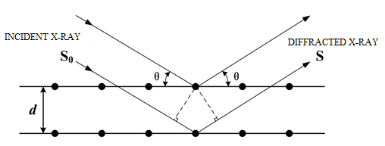

Geometrical Reflection Conditions for X-rays from a Single Crystal.
    - When θ, λ, d and n satisfy the following Bragg equation (1) at the same time, X-ray diffraction intensity of the beam is maximized:
nλ=2dsinθ (1)
Where:
θ: the angle between the incident beam and the reflecting planes. See Figure 1.
λ: the X-ray wavelength
d : the interplanar spacing. See Figure 1.
n: the diffraction order
    - For the hexagonal system of sapphire, lattice spacing d can be calculated according to equation (2):

$d=1/\sqrt{\frac{4}{3a^{2}}(h^{2}+hk+k^{2}+\frac{l^{2}}{c^{2}})}$ (2)
Where:
a and c : the lattice constants (for sapphire, a =4.758 Å, c=12.991 Å);
h, k and l: Miller indexes of the reflecting planes, respectively.
    - Values of θ for various low-order reflection planes (hkil) are given in Table 1.
              - Angle θ, interplanar spacing d and relative intensity I/I₁of some low-order reflection planes (hkil) of sapphire crystal.
reflection planes (hkil) | θ | 2θ | I/I₁ | d (Å/0.1nm)
$$01\overline{1}2$$ | 12°48′ | 25°36′ | 75 | 3.479
$$11\overline{2}0$$ | 18°55′ | 37°50′ | 40 | 2.379
$$0006$$ | 20°50′ | 41°40′ | <1 | 2.165
$$22\overline{4}0$$ | 40°21′ | 80°42′ | 7 | 1.190
$$03\overline{3}0$$ | 34°06′ | 68°12′ | 50 | 1.374
$$30\overline{3}0$$ | 34°16′ | 68°32′ | 50 | 1.373
$$20\overline{2}2$$ | 23°05′ | 46°10′ | 1 | 1.964
$$11\overline{2}3$$ | 21°41′ | 43°22′ | 100 | 2.085
$$02\overline{2}4$$ | 26°16′ | 52°32′ | 45 | 1.740
Notice: Wavelength of X-ray λ = 0.154056 nm
  - Key Parameters
    - X-ray tube anode material —X-ray tube anode material is primate material for inspiring X-ray radiation. Different anode material will be inspired to different X-ray radiation. The common anode material is Oxygen-free copper (Cu).
    - X-ray radiation wavelength — When Cu is selected as the tube anode material, it is usually the K_{α1} radiation with wavelength λ of 1.54056 Å that will be applied to determine the orientation of a sapphire single crystal.
    - X-ray beam intensity — X-ray beam intensity refers to the intensity of X-ray beam reflected from the testing sample. Its value can be adjusted by tuning X-ray tube current, X-ray tube voltage, collimator slits, etc., according to sample’s diffraction ability.
  - Apparatus
    - X-ray crystal orientation instrument with accuracy of ±30" is required. Essentially monochromatic parallel X-ray can be generated from the instrument system. The specimen is fixed in the sample-stage so that it can be rotated to satisfy the Bragg law conditions. The schematic of the apparatus and the diffraction geometry is shown as Figure 2.
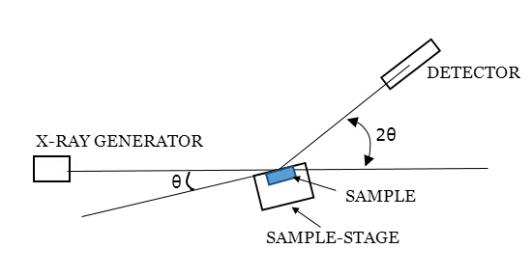
Figure 2
Schematic of the apparatus and the diffraction geometry
  - Procedure
    - Test Specimen
      - Grind the prepared plane to get high flatness and without mechanical damage.
    - Zeroing Instrument
      - Turn on the instrument and remove the slit: observe the slit with a fluorescence plate until a green circular spot can be seen.
      - Perform further adjustment by using a standard c-plane (0001) sapphire wafer. Place the standard wafer on the sample-stage and adjust the counter to 2θ = 41°40′, the goniometer to θ = 20°50′. Then rotate the sample-stage or the standard-wafer until the detector intensity reaches the maximum value. Afterwards, treat θ from 20°50′ to 0°0′, and the angle indicator of the sample-stage should be aligned with the outer zero-position "0". If not, adjust the angle pointer until it meets the alignment requirement.
    - Select the Bragg angle θ
      - Choose the Bragg angle θ according to the approximate orientation of the sample.
      - Adjust the counter position to 2θ.
    - Fix the test sample on the stage to prevent moving or slipping.
      - Especially, for sapphire ingot in big size, for instance, the sample should be fixed on a specialized holding fixture as shown in Figure 3.
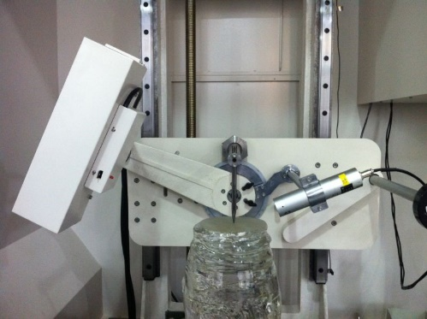
Figure 3
Holding fixture for big-size sapphire ingot.
    - Turn on the X-ray generator, and rotate the goniometer until the X-ray diffraction intensity reaches its maximum value, as when Equation (1) is satisfied.
    - Record the goniometer reading ψ₁.
    - Rotate the sample around the test surface normal (as the Z axis in Figure 4) with 90º, 180º and 270º to the same direction respectively and repeat the above steps from 6.4.3 to 6.4.5 sequentially and record the goniometer readings ψ₂, ψ₃ and ψ₄.

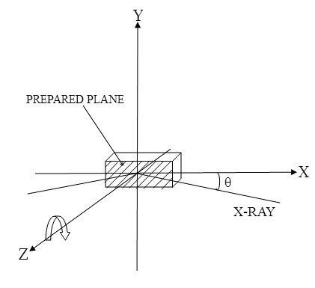
Figure 4
Schematic diagram of test, where X-Ray is in the XZ-plane.
  - Calculation
    - Calculate the angle deviation component α and β according to equation (3) and (4), respectively:
α=1/2(ψ₁-ψ₃) (3)
β=1/2(ψ₂-ψ₄) (4)
where:
α: the angle deviation component measured in the X direction as in Figure 4;
β: the angle deviation component measured in the Y direction as in Figure 4;
ψ₁, ψ₂, ψ₃ and ψ₄: the goniometer readings.
    - Calculate the total angle deviation according to equation (5):
ϕ²=α²+β² (5)
where:
ϕ: the total angle deviation, which should be smaller than 5°.
    - Calculate the instrument error as following:
δ_{α}=1/2(ψ₁+ψ₃)-θ (6)
δ_{β}=1/2(ψ₂+ψ₄)-θ (7)

  - Report
    - The report shall include the following information:
      - Material to be tested, including the shape and size.
      - Crystal reference plane (hkil)
      - Angle deviation component α and β of the prepared plane.
      - Total angle deviation ϕ of the prepared plane.
      - Date of test and identity of operator making the measurements. .

NOTICE: Semiconductor Equipment and Materials International (SEMI) makes no warranties or representations as to the suitability of the Standards and Safety Guidelines set forth herein for any particular application. The determination of the suitability of the Standard or Safety Guideline is solely the responsibility of the user. Users are cautioned to refer to manufacturer’s instructions, product labels, product data sheets, and other relevant literature, respecting any materials or equipment mentioned herein. Standards and Safety Guidelines are subject to change without notice.
By publication of this Standard or Safety Guideline, SEMI takes no position respecting the validity of any patent rights or copyrights asserted in connection with any items mentioned in this Standard or Safety Guideline. Users of this Standard or Safety Guideline are expressly advised that determination of any such patent rights or copyrights, and the risk of infringement of such rights are entirely their own responsibility.

